CO 1 - ASSESSMENT TOOL – 1
CSA-0509 Data base Management System
Student Name: K. KALYAN
Reg Num: (192525103)
Faculty Name: Dr. R Kesavan

Q1. Explain schema and instance with examples. Distinguish between logical schema, physical schema, and view schema.
Schema
A schema is the blueprint or logical structure of a database. It defines how the data is organized, including the tables, attributes (columns), relationships, constraints, and data types. A schema is designed before data is entered into the database and remains almost constant throughout the life of the database.
Characteristics of Schema
- Defines the structure of the database.
- Specifies tables, columns, relationships, and constraints.
- Changes very rarely.
- Created by the Database Administrator (DBA) or database designer.
Example
Consider a Student database.
Student Table
Student_ID | Name | Department | Age
The schema can be represented as:
STUDENT(Student_ID, Name, Department, Age)
Here,
- Student_ID → Primary Key
- Name → Student Name
- Department → Student Department
- Age → Student Age
This structure is called the schema.

Instance
An instance is the actual data stored in the database at a particular point in time. Unlike the schema, an instance changes frequently whenever records are inserted, updated, or deleted.
Characteristics of Instance
- Represents the current state of the database.
- Changes whenever data is modified.
- Also called a "snapshot" of the database.
Example
Student_ID | Name | Department | Age
101 | Rahul | CSE | 20
102 | Priya | ECE | 19
103 | Aisha | AIML | 20
If another student joins, the instance changes but the schema remains the same.

Difference between Schema and Instance
Schema | Instance
Blueprint of the database | Actual data stored in the database
Changes very rarely | Changes frequently
Created during database design | Changes whenever data is added, updated, or deleted
0Defines structure | Represents current data
Permanent | Temporary

Types of Database Schema
1. Logical Schema
The logical schema describes the logical structure of the database. It specifies tables, attributes, relationships, and constraints but does not describe how the data is physically stored.
Example
STUDENT(Student_ID, Name, Department)

COURSE(Course_ID, Course_Name)

ENROLLMENT(Student_ID, Course_ID)
The logical schema defines the relationship between Student and Course.

2. Physical Schema
The physical schema describes how the database is actually stored in memory or on disk.
It includes:
- Storage blocks
- File organization
- Indexes
- Access methods
This schema is handled by the DBMS and system administrators.
Example
The STUDENT table may be stored in a file named:
student_data.db
with B+ Tree indexing on Student_ID for faster searching.

3. View Schema
A view schema defines only the portion of the database visible to a particular user.
It improves:
- Security
- Simplicity
- Data hiding
Example
Teacher View:
| Student_ID | Name | Department |
Student View:
| Student_ID | Name |
Students cannot see confidential information such as marks or fees.

Difference between Logical, Physical and View Schema
Logical Schema | Physical Schema | View Schema
Describes logical structure | Describes physical storage | Describes user view
Independent of storage | Depends on storage | Depends on user requirements
Used by designers | Used by DBMS | Used by end users
Includes tables and relationships | Includes files, indexes, storage | Includes selected data only

Q2. Identify the entities, attributes, and relationships for a Bank Management System and construct its ER diagram.
Entities and Attributes
1.Customer
- Customer_ID (Primary Key)
- Name
- Address
- Phone
2.Account
- Account_No (Primary Key)
- Account_Type
- Balance
3.Branch
  - Branch_ID (Primary Key)
  - Branch_Name
  - Location
4. Loan
Attributes:
- Loan_ID (Primary Key)
- Loan_Amount
- Loan_Type
- Interest_Rate

5. Transaction
Attributes:
- Transaction_ID
- Date
- Amount
- Transaction_Type

Relationships
Customer — Owns — Account
One customer can own multiple accounts.
Relationship:
Customer (1) -------- (M) Account

Branch — Maintains — Account
One branch manages many accounts.
Branch (1) -------- (M) Account

Customer — Takes — Loan
A customer can take multiple loans.
Customer (1) -------- (M) Loan

Branch — Issues — Loan
A branch issues many loans.
Branch (1) -------- (M) Loan

Account — Performs — Transaction
One account performs multiple transactions.
Account (1) -------- (M) Transaction

ER Diagram
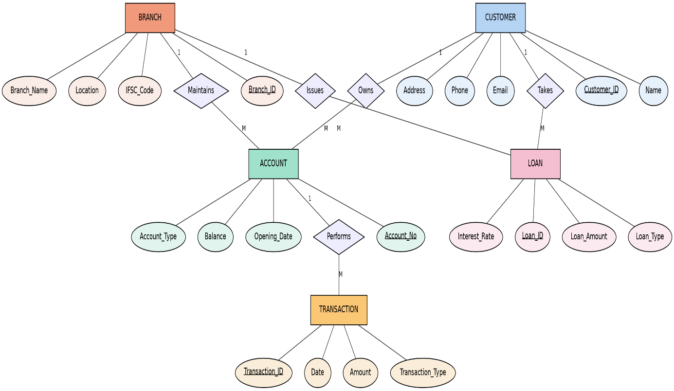

Q3. Explain the Extended ER (EER) model. Describe the concepts of generalization, specialization, and aggregation.
Extended Entity Relationship (EER) Model
The Extended ER (EER) Model is an enhancement of the ER model that provides additional features for representing complex real-world applications. It introduces concepts such as inheritance, specialization, generalization, aggregation, and categories.
The EER model allows better representation of object-oriented concepts and improves database design.

Features of EER Model
- Supports inheritance.
- Represents superclass and subclass.
- Reduces data redundancy.
- Handles complex relationships.
- Improves database organization.

1. Generalization
Generalization is the process of combining two or more lower-level entities into a higher-level entity based on common properties.
Example
Car
Bike
Truck

↓

Vehicle
All vehicles have common attributes like:
- Registration Number
- Color
- Manufacturer
Hence they are generalized into Vehicle.

2. Specialization
Specialization is the opposite of generalization.
A higher-level entity is divided into lower-level entities based on distinguishing characteristics.
Example
Employee

↓

Manager
Developer
Clerk
All employees have:
- Employee_ID
- Name
Managers additionally have:
- Bonus
Developers have:
- Programming Language

3. Aggregation
Aggregation treats a relationship between entities as a higher-level entity so that it can participate in another relationship.
Example
Employee works on Project.
The relationship "Works_On" is aggregated and connected with Department.
Employee ---- Works_On ---- Project
|
|
Department
Aggregation is useful when relationships themselves need to participate in other relationships.

Advantages of EER Model
- Better representation of real-world systems.
- Supports inheritance.
- Eliminates redundancy.
- Simplifies complex databases.
- Easier maintenance.

Q4. Design an EER diagram for a Hospital Management System incorporating inheritance and weak entities.
Hospital Management System
A Hospital Management System stores patient details, doctor information, departments, appointments, and medical records.

Superclass
Person
Attributes:
- Person_ID
- Name
- Gender
- Age
- Address

Subclass 1: Doctor
Attributes:
- Doctor_ID
- Specialization
- Salary
- Experience

Subclass 2: Patient
Attributes:
- Patient_ID
- Disease
- Admission_Date
- Blood_Group

Department
Attributes:
- Department_ID
- Department_Name
- Location

Weak Entity: Medical Record
Medical Record cannot exist without Patient.
Attributes:
- Record_No (Partial Key)
- Diagnosis
- Prescription
- Test_Result
Weak Entity depends on Patient.

Relationships
Person → Doctor
Inheritance (IS-A)
Person → Patient
Inheritance (IS-A)
Doctor Works In Department
One department has many doctors.
Patient Has Medical Record
One patient has many medical records.
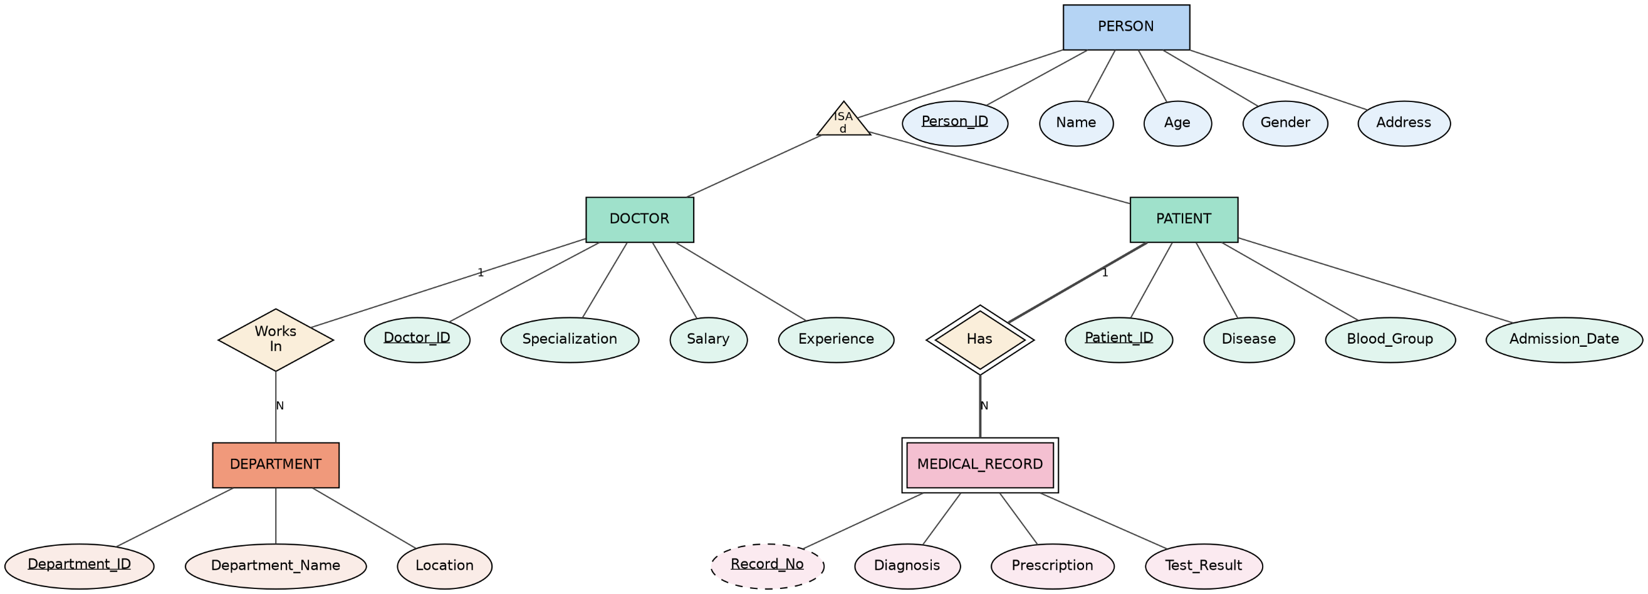

Q5. Explain the role of a DBA (Database Administrator) and the responsibilities associated with the position.

Database Administrator (DBA)
A Database Administrator (DBA) is a professional responsible for installing, configuring, maintaining, securing, and managing database systems. The DBA ensures that databases are available, reliable, secure, and perform efficiently for users and applications.

Roles of a DBA
- Designs and manages databases.
- Ensures data security and privacy.
- Maintains database performance.
- Performs backup and recovery.
- Monitors database availability.
- Supports application developers.
- Prevents unauthorized access.

Responsibilities of a DBA
1. Database Installation and Configuration
- Install DBMS software such as MySQL, Oracle, SQL Server, or PostgreSQL.
- Configure database settings for optimal performance.
2. Database Design
- Create databases, tables, indexes, views, and relationships.
- Define constraints and normalization rules.
3. Security Management
- Create user accounts and roles.
- Assign permissions and privileges.
- Protect sensitive data using authentication and encryption.
4. Backup and Recovery
- Schedule regular backups.
- Restore databases after failures or accidental data loss.
- Maintain disaster recovery plans.
5. Performance Tuning
- Monitor slow queries.
- Create indexes.
- Optimize SQL queries and storage.
6. Data Integrity
- Ensure data remains accurate, consistent, and reliable.
- Enforce primary key, foreign key, and integrity constraints.
7. Monitoring and Troubleshooting
- Monitor database health and storage usage.
- Detect and resolve database errors, crashes, or deadlocks.
8. Storage Management
- Allocate sufficient disk space.
- Manage database files and memory usage.
- Plan future storage expansion.
9. High Availability
- Implement replication, clustering, and failover mechanisms.
- Minimize database downtime.
10. Documentation
- Maintain records of database configurations, backups, security policies, and recovery procedures.

Advantages of Having a DBA
- Improved database security.
- Faster database performance.
- Reduced risk of data loss.
- Better backup and disaster recovery.
- High database availability.
- Efficient resource utilization.
- Reliable and consistent data management.

